- Purpose
  - The purpose of this document is to describe the procedure for assembling the Console on the Genesys Machine.
- Scope
  - This SOP applies to all equipment assembly team members. The process applies to the following machine ID’s:
EP50317EQS0600BE1200 – Standard Controls/BDI Assembly (MSAS)
EP50356EQS0600BE1200 – Standard Controls/BDI Assembly (G20)
EP50357EQS0600BE1200 – Standard Controls/Pad Assist
- Responsibilities
  - The operations manager/supervisor is responsible for enforcing this SOP.
- Materials
  - The proper materials needed for this process are listed on the machine work order.
- Definitions

- Procedure
  - Take a console panel (E29322) and spray soapy water onto it. Take a decal (E28794 – MSAS and G20 Traction / E29008 – G20 Pad Assist) and place it onto the panel and position it properly. It should slide due to the soap. Ensure the holes are aligned and that the decal does not hang over the edges. You should see the edge of the panel all the way around the outside of the decal. Once positioned, use a squeegee to smooth the label and push out the water. Dry the panel off. There should be no bubbles or defects on the face.
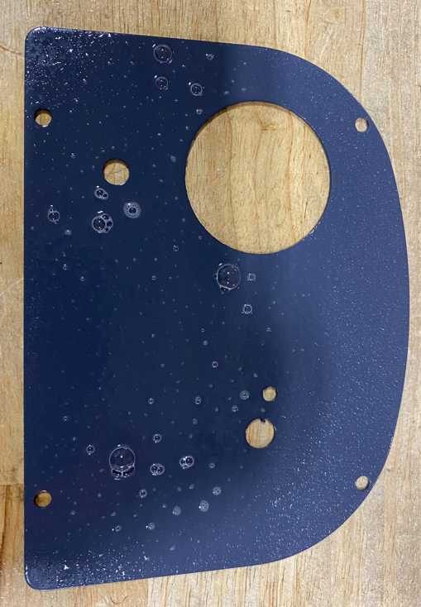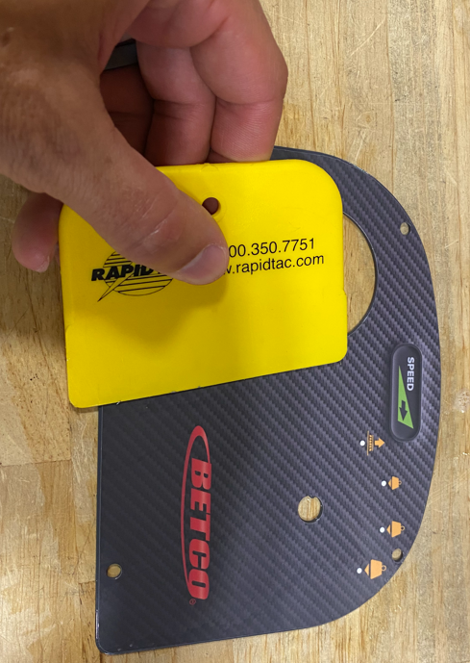
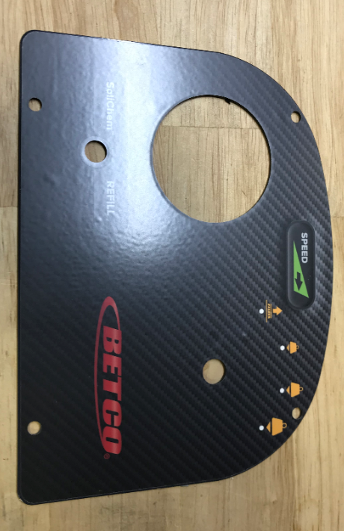
  - Install a battery gauge (E12630) into the appropriate hole. Use the supplied mounting bracket. You do not need to use the o-ring that comes with it. Set the dial on the back to 1 for Wet Batteries. If the machine this is installed on has AGM batteries set the dial to 4, this setting will be changed at assembly.

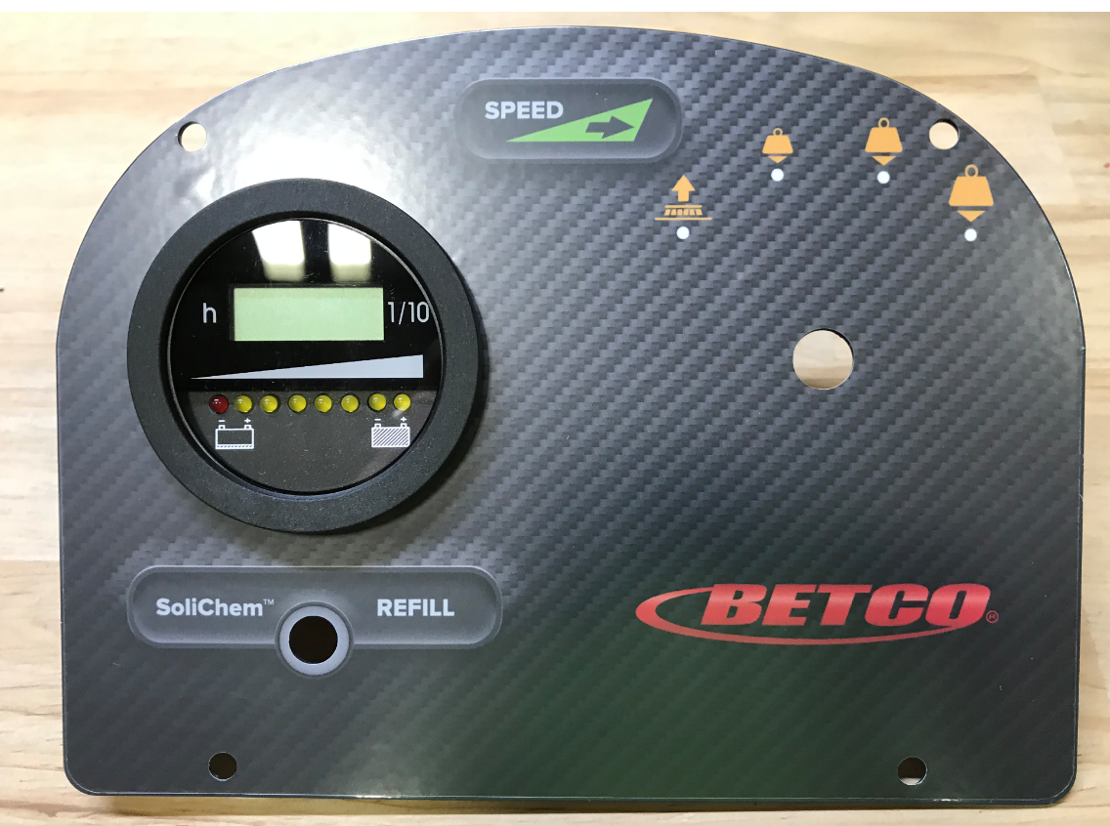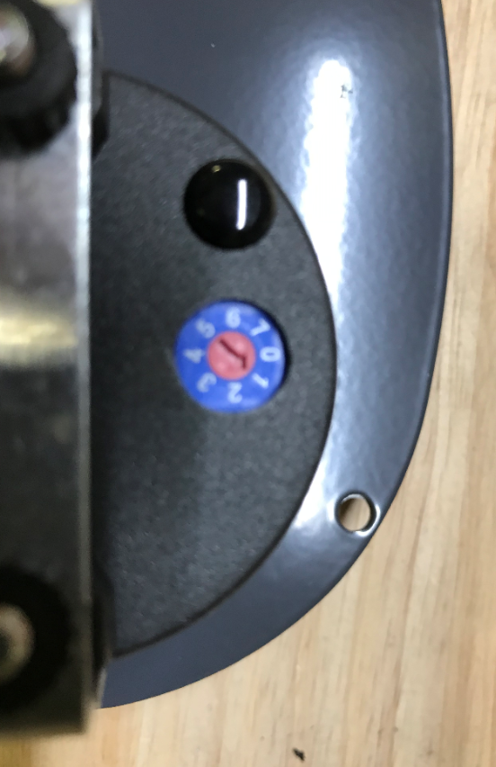

  - If a G20 pad assist unit is being built, skip to step 7.
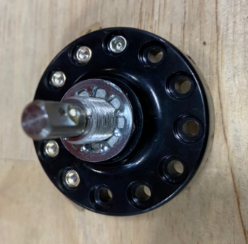
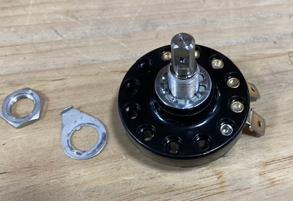
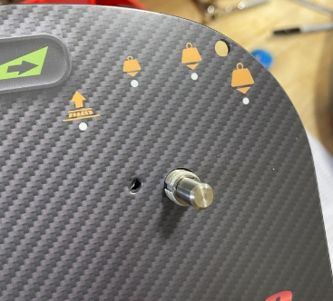
  - For a MSAS or G20 Traction unit, get a down pressure rotary switch (E29323). Verify if the switch has a dimple. If dimple is not present, follow SOP EQ 108 for instructions. Remove the supplied nut and locating tab. Place a serrated washer (E28991) over the switch and feed it through the hole in the panel. Ensure the tab in the hole on the panel lines up with the groove on the switch.

  - Place the locating tab back over the nose of the switch and align it with the hole in the plate. Install the supplied nut and tighten. Do not overtighten or the decal can wrinkle.

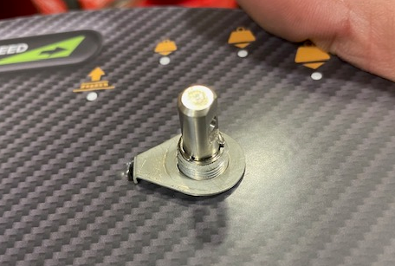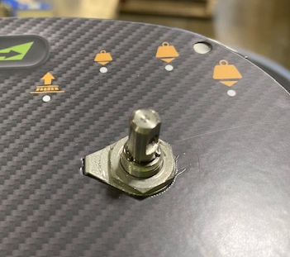

  - Install the switch knob (E29324) using a set screw (E28788). Put some blue Loctite on the set screw. Ensure that it is properly tightened to avoid it falling off or loosening. The set screw should tighten into the drilled dimple in the switch shaft. Wiggling the knob while tightening can help ensure the set screw properly finds the dimple.
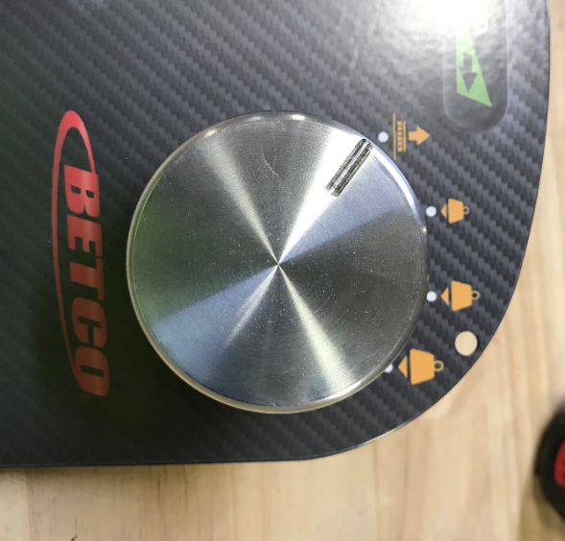
  - If the machine is equipped with Solichem, install a Solichem Indicator LED (E29344) using the supplied washer and nut.

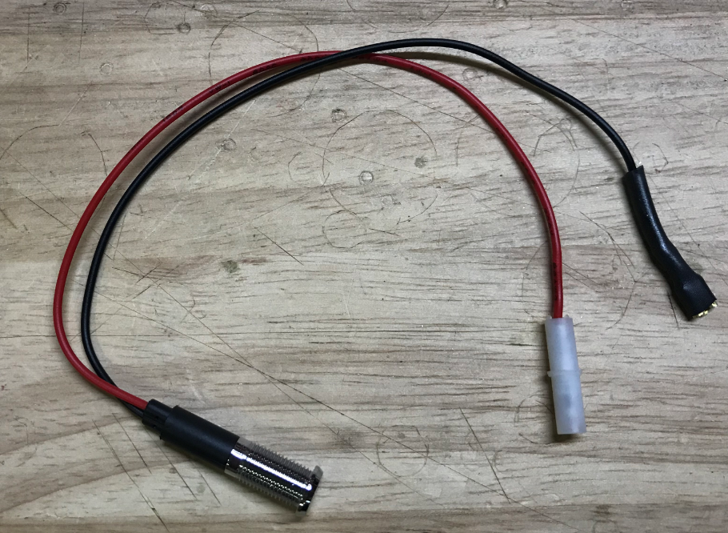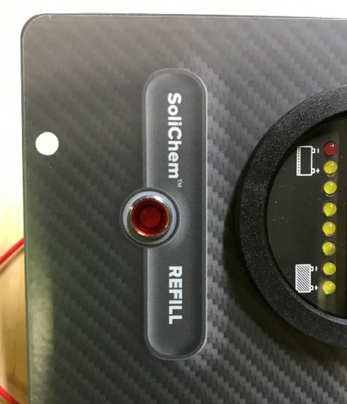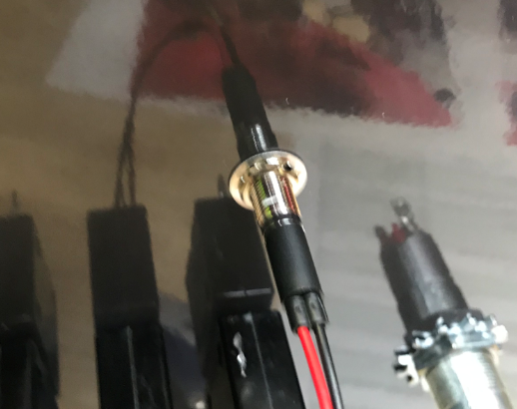
- References (optional section as needed)

- Training Guide

Functional Training Groups Requiring Training
Equipment Assembly Group

- SOP Change Control

Date of Change | Reason for Change
Rev 01 | This is the first version of the S.O.P. hence there are no revisions to this document.
Rev 02 - 8/13/2021 | Added QC Checks. Added new label application method.
Rev 03 - 11/2/2023 | Updated steps for current process.
Rev 04 - 4/2/2025 | Combined MSAS and G20 instructions

Approvals

Submitter/Author Approval:__________________________________ Date:______________________

Management Approval:______________________________________ Date:______________________

QAU Approval:_____________________________________________ Date:______________________

